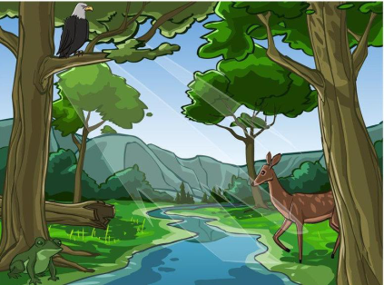
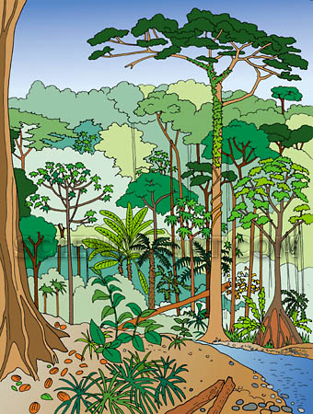
A Visit to the Forest: Written Reports
Name: ________________________________
Date: ____________________ Points _______
Teacher:

CATEGORY | 4 | 3 | 2 | 1
Scientific Concepts | Report illustrates an accurate and thorough understanding of scientific concepts underlying the topic/lab.. | Report illustrates an accurate understanding of most scientific concepts underlying the topic/lab. | Report illustrates a limited understanding of scientific concepts underlying the topic/ lab. | Report illustrates inaccurate understanding of scientific concepts underlying the topic/ lab.
Question/Purpose | The purpose of the work/lab is very clearly defined, and the questions to be answered are clearly identified, stated and answered. | The purpose of the work/lab is well defined, and the questions to be answered are identified, but are stated in a somewhat unclear manner. | The purpose of the work/lab is partially defined, and the questions are partially identified, but are stated in an unclear manner. | The purpose of the work/lab is unclear, and the questions to be answered are erroneous or  irrelevant.
Analysis | All information is clearly discussed and analyzed. Predictions and inferences are made based on the facts. | The information is satisfactorily and analyzed. There is some effort in building predictions and inferences. | The information is somewhat discussed but not analyzed. There is a minimal attempt to make predictions and inferences. | The information is not discussed or analyzed. There is no attempt to make predictions or inferences. The information seems to be copied.
Data | Professional looking and accurate representation of the data in tables and/or graphs. Graphs and tables are labeled and titled. | Accurate representation of the data in tables and/or graphs. Graphs and tables are labeled and titled. | Accurate representation of the data in written form, but no graphs or tables are presented. | Data are not shown or are inaccurate.
Drawings/Diagrams | Clear, accurate diagrams are included and make the information easier to understand. Diagrams are labeled neatly and accurately. | Diagrams are included and are labeled neatly and accurately. | Diagrams are included and are labeled. The quality of the diagrams and labels is very lmited. | Required diagrams are missing or are missing important labels.
Appearance/Organization | Report is very well written and complete, and uses headings and subheadings to visually organize the material. | Report is well written and uses headings and subheadings to visually organize the material. | Report is written, but the information has gaps. The material is not organized using headings and subheadings. | Report is poorly written and follows no organizational pattern.
Rubric adapted from rubistar.4teachers.org

A Visit to the Forest: Oral Presentation
Name: ________________________________
Date: ____________________ Points _______
Teacher:

CATEGORY | 4 | 3 | 2 | 1
Content | Shows a full understanding of the topic. Provides more than required academic information. | Shows a good understanding of the topic. Provides the required academic information. | Shows a good understanding of parts of the topic. Provides less than required academic information. | Does not seem to understand the topic very well. Provides limited or none academic information.
Vocabulary | Uses more than required academic vocabulary Extends audience vocabulary by clearly defining five or more new words.. | Uses required academic vocabulary. Includes three or four words that might be new to most of the audience. Provides a somewhat clear definition. | Uses less than required academic vocabulary. Includes one or two new words, with a vague definition. | Uses limited or no academic vocabulary. Does not introduce new words to the audience.
Speaks Clearly | Speaks clearly and distinctly all the time (100-95%). Faces the audience all the time. | Speaks clearly and distinctly most of the time (80-90%). Faces the audience most of the time. | Speaks clearly and distinctly some of the time (70-80%). Has limited visual contact with the audience. | Speaks in an inarticulate way, or less than a 60% of the time. Has little or no visual contact with the audience.
Volume | Volume is loud enough to be heard by all audience members throughout the presentation. | Volume is loud enough to be heard by all audience members at least 90% of the time. | Volume is loud enough to be heard by all audience members at least 80% of the time. | Volume often too soft to be heard by all audience members.
Props | Student uses several props (could include costume) that show considerable work/creativity and which make the presentation better. | Student uses two props that show work/creativity and which make the presentation better. | Student uses 1 prop which makes the presentation better. | The student uses no props OR the props chosen detract from the presentation.
Collaboration with Peers | Almost always listens to, shares with, and supports the efforts of others in the group. Takes a lead role in keeping people working well together. | Usually listens to, shares with, and supports the efforts of others in the group. Integrates well with the group. | Often listens to, shares with, and supports the efforts of others in the group but sometimes is not a good team member. | Rarely listens to and supports the efforts of others in the group. Often is not a good team member, and collaborates poorly with rest of team..
Rubric adapted from rubistar.4teachers.org
A Visit to the Forest: Graphic Work
Name: ________________________________
Date: ____________________ Points _______
Teacher:

CATEGORY | 4 | 3 | 2 | 1
Graphics - Relevance | All graphics are related to the topic and all clarify meaning. All borrowed graphics have a source citation. | All graphics are related to the topic and most clarify meaning. All borrowed graphics have a source citation. | All graphics relate to the topic but do not clarify meaning. Most borrowed graphics have a source citation. | Graphics do not relate to the topic, do not add to meaning, or are non-existent.Borrowed graphics do not have a source citation.
Content - Accuracy | At least 7 accurate facts are displayed on the poster. | 5-6 accurate facts are displayed on the poster. | 3-4 accurate facts are displayed on the poster. | Less than 3 accurate facts are displayed on the poster.
Knowledge Gained | All graphics are related to facts and processes displayed in the poster: 100% | Most of the graphics are related to facts and processes displayed in the poster: 75% | Some of the graphics are related to facts and processes displayed in the poster: 50% | Few or none of the  graphics are related to facts and processes displayed in the poster: 25% or less.
Labels | All items of importance on the poster are clearly labeled. | Almost all items of importance on the poster are clearly labeled. Some key information is missing. | Several items of importance on the poster are clearly labeled. Half of the key information is missing. | There are few or no labels, and few or none provide key information.
Graphics - Originality | Several of the graphics used on the poster reflect a exceptional degree of student creativity in their creation and/or display. | One or two of the graphics used on the poster reflect student creativity in their creation and/or display. | The graphics are made by the student, but are based on the designs or ideas of others. | No graphics made by the student are included.
Required Elements | The poster includes all required elements as well as additional information. | All required elements are included on the poster. | All but 1 of the required elements are included on the poster. | Several required elements were missing.

Rubric adapted from rubistar.4teachers.org

